**3. Project Design**

**3.1 PROBLEM DEFINITION**

The courier management system is supposed to be effective and utilize the resources in an optimum manner to ensure timely service with least cost. Every aspect of the operation from pickup/received must be logged properly. The movement of goods between hubs or zones will have a time limit set under which it must be completed. Any packages which remain undelivered or unclaimed will be notified to the receiver first and then the sender. The receiver will be sent a tracking ID by the courier service company through SMS/email. This can be used to track its movement. The design and implementation of this system will be the goal of this project.

**3.1.1 DISADVANTAGES OF EXISTING SYSTEM**

1. Single Centralized Database

2. High rate of failure

3. Corruption of Data

4. Cause confusions in case of delays or disputes

**3.2 SOFTWARE REQUIREMENT SPECIFICATION (SRS)**

**3.2.1 SCOPE AND PURPOSE**

Existing system has a lot of disadvantages mentioned above, the purpose of this project is to overcome the problems of existing system. The ‘Courier Tracking System’ has been developed to override the problems prevailing in the practicing manual systems. It allows customers to visit the website and enter their package id to track their parcel. The status of their consignment is then visible to the customer. The system will manage various activities like:

1. Maintaining details of branches.
2. Maintaining details of staff.
3. Maintaining details of parcels.
4. Parcel tracking by customers as well as admins.
5. Maintaining daily records of parcels.

**3.2.2 STRUCTURE OF TRACKING PARCEL**



**Fig. Tracking Parcel Button**

1. **Tracking Button –** Customers will go to our website and can click on the track button to track their parcels.
2. **Tracking Structure –** After clicking the above Tracking button the website will redirect you to the tracking parcel page.

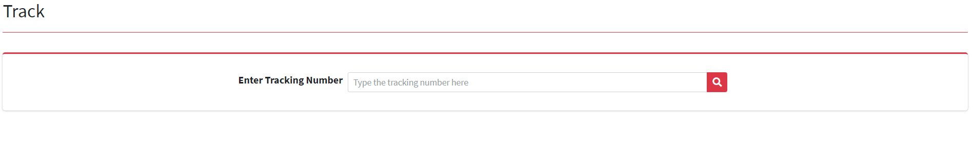

**Fig. Tracking Structure**

Here, customers will enter their Parcel Tracking ID and can track their

parcel.

1. **Tracking of Parcel –** After entering the Parcel Tracking ID the tracking status of the parcel will be displayed like shown below:

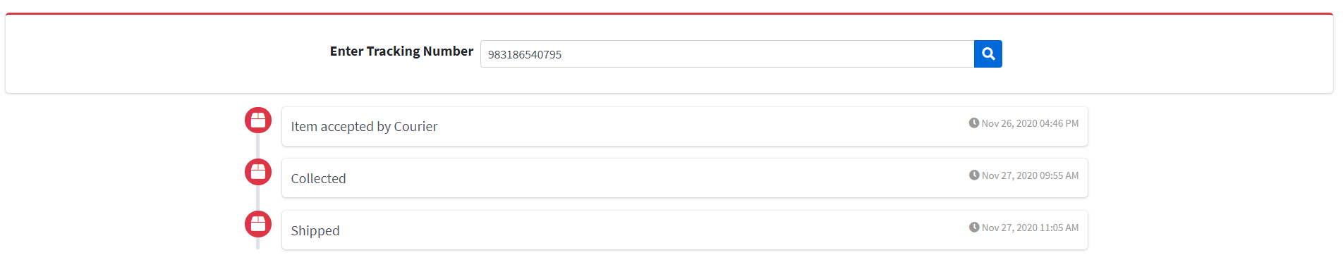

**Fig. Tracking Status of Parcel**

**3.2.3 FEATURES**

1. Maintaining Client Database.
2. Maintaining Package Database
3. Maintaining Employee Database
4. Courier Tracking
5. SMS & Email Notifications
6. Variations For Delivery Service Rates
7. Billing feature

**3.2.4 SOFTWARE AND HARDWARE REQUIREMENTS**

1. **SOFTWARE REQUIREMENTS**
2. HTML5 5. Google API
3. CSS3 6. XAMPP Server
4. PHP 7. MySQL
5. AJAX 8. Web Services

1. **HARDWARE REQUIREMENTS**
2. Computer – Core i5, HDD: 1TB, SSD: 256GB, RAM: 8GB

**3.3 ADVANTAGES**

1. Less time consuming.

2. Customers don’t have to call each time to the company for parcel tracking

details.

3. Inexpensive order tracking for customers.

4. Secure tracking.

5. Easy to maintain the details of branches, staff and parcels.

**3.4 DISADVANTAGES**

1. There can be a case where the Parcel may not be tracked properly due to

system error.

2. Delay in delivery due to unforeseen error or trouble.

3. Tracking is functional only for smartphone and computer users.

**3.5 FUNCTIONAL AND NON-FUNCTIONAL REQUIREMENTS**

1. **FUNCTIONAL REQUIREMENTS**
2. Tracking Facility
3. Parcel Details should be provided when Parcel ID is provided
4. Only admin can add and delete the records.
5. Customers should track only their parcels.
6. **NON-FUNCTIONAL REQUIREMENTS**
7. Security
8. Platform Independence
9. Easy to track parcel details
10. Performance

**3.6 PROJECT PLAN**